

**SIES (Nerul) College of Arts, Science and Commerce**  
**NAAC Re-Accredited ‘A’ Grade**

**Sri Chandrasekarendra Saraswathy Vidyapuram,**  
**Plot 1-C, Sector V, Nerul, Navi Mumbai-400 706**

**PROJECT REPORT**

**ON**

**2D PC Game**

**SUBMITTED**

**TO**

**UNIVERSITY OF MUMBAI**

**BY**

**Gaurav Mishra**

**(TYBSc.Computer Science)**

**2019-2020**



**SIES (Nerul) College of Arts, Science and Commerce**  
**NAAC Re-Accredited ‘A’ Grade**

**Sri Chandrasekarendra Saraswathy Vidyapuram,**  
**Plot 1-C, Sector V, Nerul, Navi Mumbai-400 706**



This is to certify that the project entitled “**Pong Game”** developed in Unity using Visual Studio is successfully completed by **Mr. Gaurav Mishra** Third Year Bachelor of Science (Computer Science) as per the requirement of University of Mumbai in part fulfilment for the completion of Degree of Bachelor of Science (Computer Science). It is also to certify that this is the original work of the candidate done during the academic year 2019-2020.

Seat No:

Date of Submission:

Prof. Padmaleela Damaraju Prof. Padmaleela Dhamaraju  
(Project Guide) Coordinator)

Date: _______ Date: _______

External Examiner

Date: _______ (College Seal)

**PREFACE**

**In these modern era people of the world are living a pretty stress filled life because of work, pressure and other problems**

**Everyone needs a form of entertainment in their life.**

**Some like to watch Movie or tv series for relaxation while some like to play video games.**

**Video games are a fun way to relax and connect friends from all over the world.**

**Some games improve the thinking ability of the players**

**ACKNOWLEDGEMENT**

**Success can never be achieved single handed so, it is our duty to acknowledge all those who have provided a helping hand in making this project success. I grab this opportunity to convey my immense regards towards all the distinguished people who have their valuable contribution in the hour of need.**

**I profoundly thank our principal Dr. Milind Vaidya for giving us support throughout the course and made us capable of being worthy of recognition and extended query facility to us for making and computing this project smoothly.**

**I would like to express our sincere thanks to Prof. Padmaleela Damaraju (Head of CS Department) for her constant encouragement, which made this project a success.**

**I am highly obliged to Prof. Padmaleela Damaraju, teaching staff member of the Computer Science department, who spread efforts in making the project a successful one with her guidance, appropriate advice and encouragement and of course the inspiration without which the project would be ineffective difficult task.**

**I sincerely thank and express my profound gratitude to our teachers for their timely and prestigious guidance. I also thank my family members for their continued support in completing this project work and last but not the least; I wish to thank all my friends and well-wishers who are directly or indirectly linked with the success of our project.**

**By,**

**Gaurav Mishra**

**Index**

1. **Synopsis**
   1. **Title of project**
   2. **Why this project chosen?**
   3. **Objective and scope**
2. **Methodology**
   1. **Hardware**
   2. **Software**
   3. **Programming language**
3. **Phase 1: The planning**
   1. **What is game?**
   2. **Background**
   3. **Game design and concepts**

**3.4 Software used**

**3.4.1 Unity**

**3.4.2 Visual studio 2017**

1. **Phase 2: Design Phase**
   1. **Gantt chart**
   2. **Creating the basic level**
   3. **Creating Paddles and Ball**
   4. **Moving of Paddles and Ball**
   5. **Right player wins**
   6. **Left player wins**
2. **Phase 3: Implementation of code**
   1. **Coding of GameManager**
   2. **Coding of Paddle**
   3. **Coding of Ball**
3. **Phase 4: Testing**
4. **Referencess**
5. **SYNOPSIS OF THE PROJECT**
   1. **TITLE OF THE PROJECT**

**Pong Game 2D**

1. **2 WHY IS THE PARTICULAR TOPIC CHOSEN?**

**This topic is chosen to make people understand what is gaming and how games are created. Games are creative way to immerse in the entertainment in their leisure time.**

1. **3 OBJECTIVE AND SCOPE OF THE PROJECT**

**OBJECTIVE**

**Proposed system has following objectives**

* **To develop a game for the entertainment of the player.**
* **To create a ball and paddles to play**
* **It is a double player game**
* **It is created to play in a free time**

1. **METHODOLOGY**

**Prototyping methodology shall be used as it allows the developer to create solutions in parts to demonstrate functionality and then make needed refinements before developing the final solution.**

* 1. **HARDWARE & SOFTWARE USED**
  2. **HARDWARE**

|  |  |  |  |
| --- | --- | --- | --- |
| * **Processor:** |  |  | **Hp i3 8400 processor with 6 cores.** |
| * **Clock Speed:** |  |  | **2.81 GHz CPU** |
| * **RAM:** |  |  | **Corsair Vengeance 8GB 2400 Mhz DDR4 Ram** |

* **Hard Disk Utilization: 10 GB or above**
  1. **SOFTWARE (S)**
* **Operating System: Windows 10**
* **Microsoft Visual Studio 2017**
* **Unity 3D**
  1. **Programming Language :**
* **Visual Studio**
* **C#**

|  |
| --- |
| **3.Phase1- The Planning of “Pong Game 2D”** |

**This phase covers my project idea along with background study of the game engines, rendering engines used in developing my own project game and also the games developed in game industry.**

* 1. **What is a Game?**

**In an era of developing technologies and software engineering, development, there is even rapidly growing sector known as The Game Development. Now you may ask what is game? The answer is “*A game is the execution of various codes and compilers through which players or the user can interact with objects displayed on the screen just for his/her entertainment.*”**

**A video game is essentially a form of entertainment, but refers not only to games played on a personal computer, but also to games run by a console or arcade machine. Today computer gaming is a big business, and there are millions of different computer games that are enjoyed by people of all ages.**

**Games are much more than a software exported into .exe files. Games come with a lot of contents in it which makes it more enjoyable such as modern games hire world’s top music composers like Hans Zimmer, Bryan Tyler, Jesper Kyd to compose music for the in-game levels Background scores etc.**

**Modern Games are built with powerful game engines which help the developers create a massive open world environment for the user to immerse in for a best experience of computer entertainment possible. The features for games to be popular are**

1. **3D Graphics: All 3d games include 3d models, meshes and textures which gets rendered in the game.**
2. **Impressive result: Whoever plays the game must get impressed by the game mechanics which makes the player comeback and play more thus making it more popular**
3. **Graphical effects: To achieve the best and impressive result, game dev’s need to add modern graphic effects such as real-time rendered shadows, ambience, occlusion, motion blur.**
   1. **Background of my project**

**This is the simple background of my project**

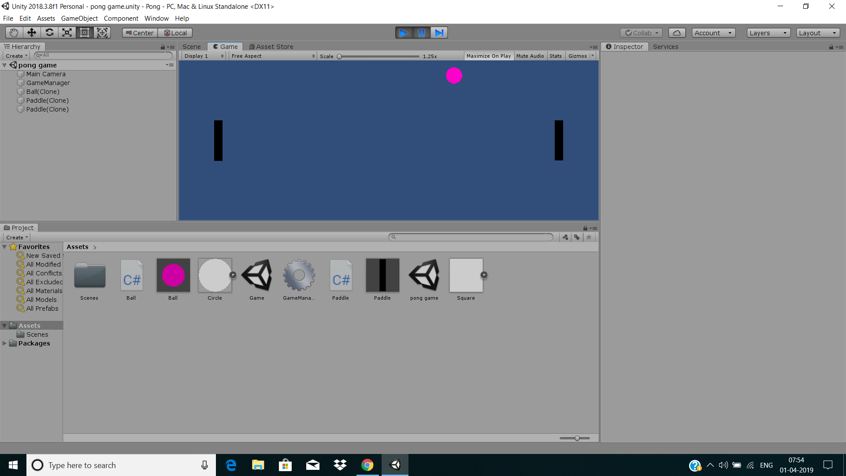

* **3.3 Game Design and Concepts**

**Today, the name of the game is Pong. We’re going to be**

**using Unity 2018.3 or later, and we’ll use Visual Studio as our coding language. No prior experience with Unity or Visual Studio is required. It will only take you about two hours to complete the tutorial, and at the end you’ll have made your own version of Pong!**

**First, let’s think about the pieces and parts of Pong – the individual “mechanics” (the rules and features of the game) that we’ll need to program.**

1. **You have a Background to play on**
2. **You have a set of Paddles that go up and down**
3. **You have a ball that bounces off walls and paddles**
4. **You have a set of side walls that you hit to score**
5. **You have a score at which you win**
6. **You have a reset button so you can play again**

**3.4 Software’s Used**

**3.4.1- Unity 3D**

**Unity 3d is the game engine on which the game was built and developed on. This software has tons of features such as post processing etc.**

**3.4.2 - Visual Studio 2017**

**This is the software used to create scripts for the game.**

* **Game Engines**
* **What is a Game Engine?**

**A Game Engine is a software that helps providing the game developers and designers with the necessary set of features, tools, etc. to build the game more quickly and efficiently.**

**Game Engines are a framework for the game development process that supports multi core area of development. Game Engines enables us to import art, assets which could be either 2d or 3d from other software’s such as Adobe Photoshop, Premier, Maya and Blender.**

**This asset which are later imported into Game Engines helps us to assemble those assets into scenes and environments, add lightings, audio, special effects, physics and animation.**

**Most modern game development studios create their own game engines for any particular game. Let’s take a game for example**

* **GTA V is a popular game developed by Rockstar Games studios. Now this game is one of the best example of modern open world games with ultra-realistic textures, models. Rockstar studios instead of depending on popular game engines like Unity, Unreal Engine, decided to create their own game engines full of the features they want to import into their game. They called this game engine as “RAGE Game Engine”, Abbreviation for Rockstar Advanced Game Engine.**
* **The Rockstar Advanced Game Engine is a proprietary game engine developed by RAGE Technology Group, a division of Rockstar Games' Rockstar San Diego studio**

**To Save time in my development process, I chose to use Unity 3d to develop my game.**

**3.4.1 Unity 3d**

**Unity is a cross-platform game engine used to develop games which was developed by Unity Technologies.**

**Unity was first announced and released in June 2005 in the Apple Inc’s worldwide developers conference as an Operating System exclusive game engine. But now in 2018, Unity has extended its support to 27 platforms such as windows, mac, consoles like Sony’s Playstation4 and Playstation4Pro and Microsoft’s Xbox consoles.**

**Unity was developed in C++ language but it has been supporting a lot of programming languages such as JavaScript, Python and C#.**

**Unity3D is a very powerful cross-platform 3D engine which has a user-friendly environment which is easy for every beginner but is powerful enough for the experts. Unity is free but there are pro versions with a variety of features and tools but it costs a monthly subscription.**



**3.4.2 Visual Studio 2017**

**Microsoft Visual Studio is development integration environment created by Microsoft. It is mainly used to develop websites, as well as computer programs, web apps, web services and mobile apps.**

**It can create both managed code and native code.**

**Visual studio comes with a code editor which supports IntelliSense and code refactoring.**

**The integrated debugger works as machine-level debugger and a source-level debugger.**

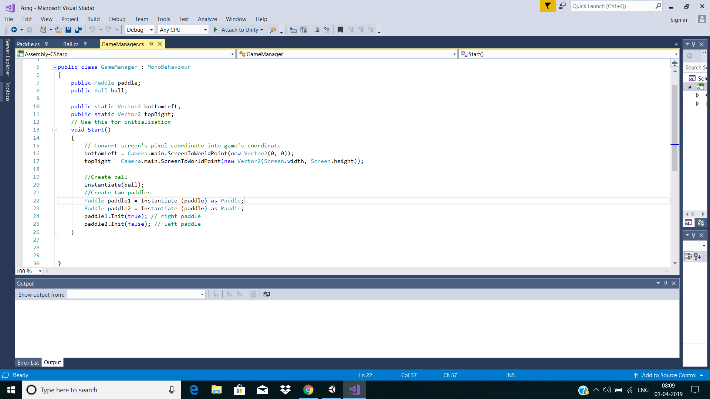

* **C# programming language**

**C# is a programming language by Microsoft which is at the core of the .net framework. Although C# is capable of cross-platform, it is widely used by developers within the Microsoft ecosystem.**

**C# was developed by Microsoft and is mostly used in all of their products. It is mainly used for developing desktop apps, and windows 8/10 apps.**

**C# is a hybrid of C & C++ language developed to compete with Sun’s Java Language.**

**Scripts in Unity are written in a special language which Unity can understand. The languages Unity operates are Object-oriented scripting languages.**

**And since C# is a good object-oriented programming language, I have chosen C# as**

**The programming language I would work with.**

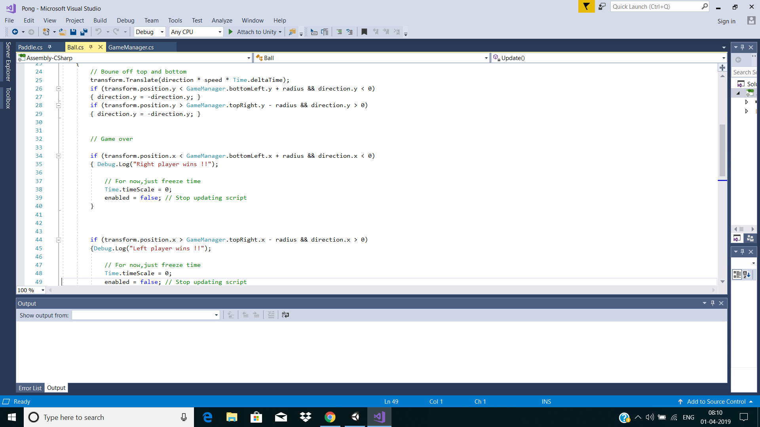

|  |
| --- |
| **4. Phase 2:- The Design Phase** |

|  |
| --- |
| **Estimate Time**  **Actual Time** |

**4.1 Gantt Chart for game development**

|  |  |  |
| --- | --- | --- |
| **MONTH**  **PHASES** | **August** | **September** |
| 1. **Planning** |  |  |
| 1. **Design** |  |  |
| 1. **Coding** |  |  |
| 1. **Testing** |  |  |

**This is my gantt chart for development of my game.**

* 1. **Creating the basic Level:**

**The goal of this designing phase was to create a very small basic level with some props and functions added to the paddle.**

**It began with creating a small Circle and then extending it to a Ball so that it can be used to bounce on from one place to another while playing.**

**This is by far the most easy task in creating a level.**

**This is how the game in the beginning looked without a Ball and Paddles while making a project.**

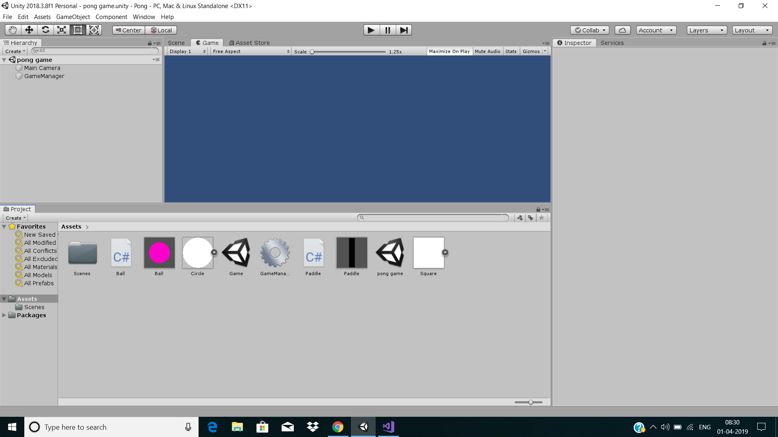

**4.3 creating Paddles and Ball**

**After this step,by instantiating circle and square in visual studio we get paddle on both the sides of wall and ball in the middle of the game.**

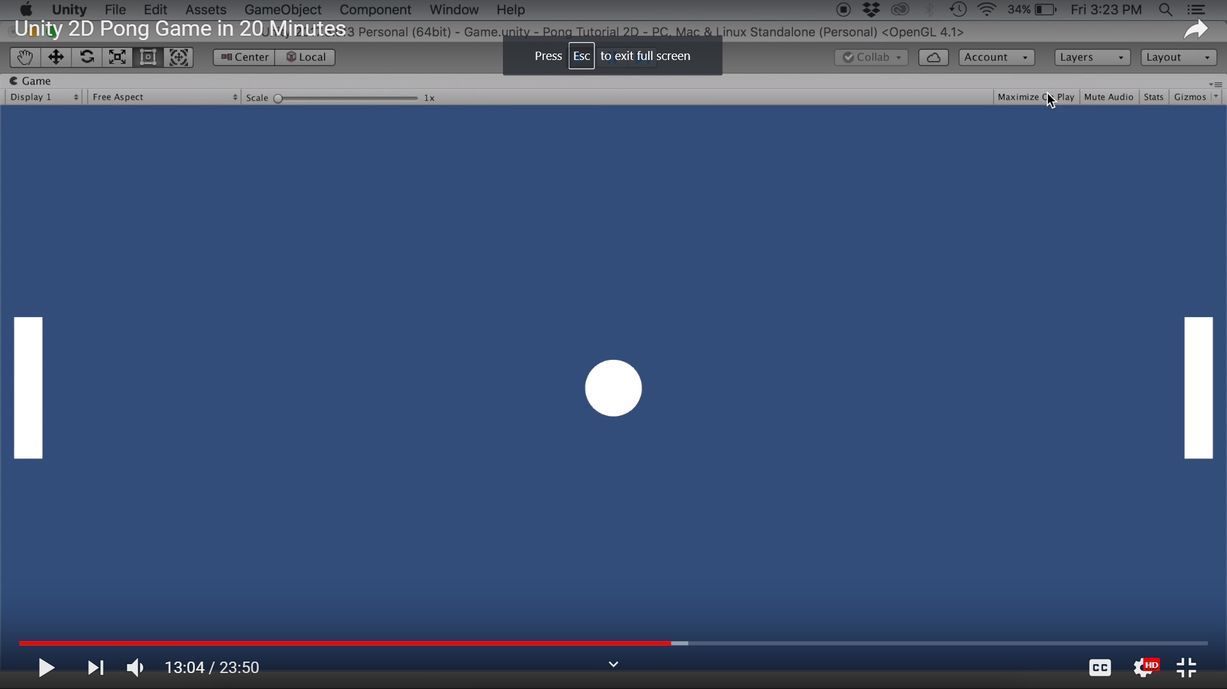

**4.4 Moving of paddles and ball:**

**After succesful coding we are allowed to move paddles and ball from one place to another.Ball moves randomly by hitting walls and collides with paddles.In this way game is ready to play.**

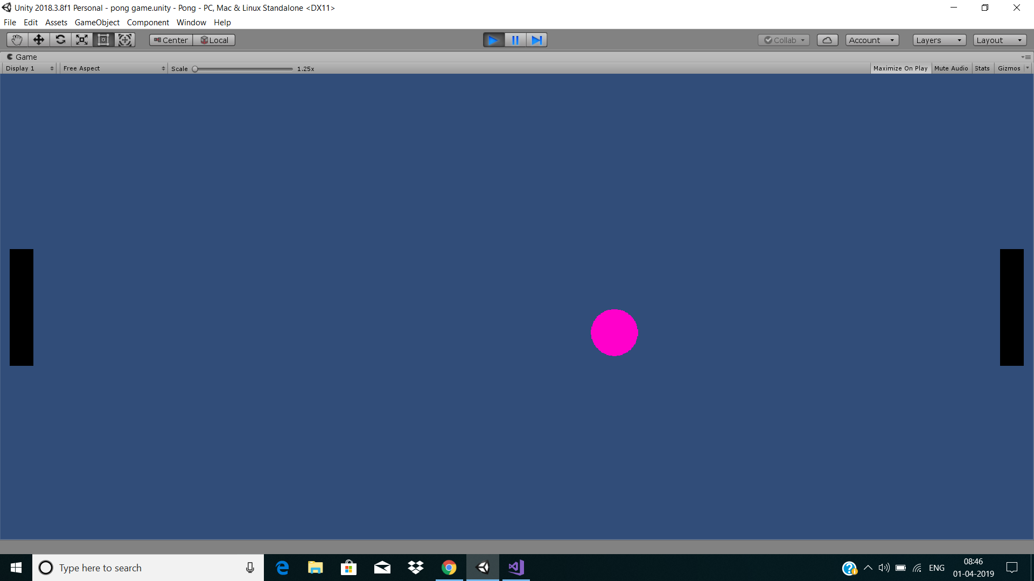

**4.5 Right player wins:**

**When the ball is missed by Left paddle.The result will be shown as Right player wins.**

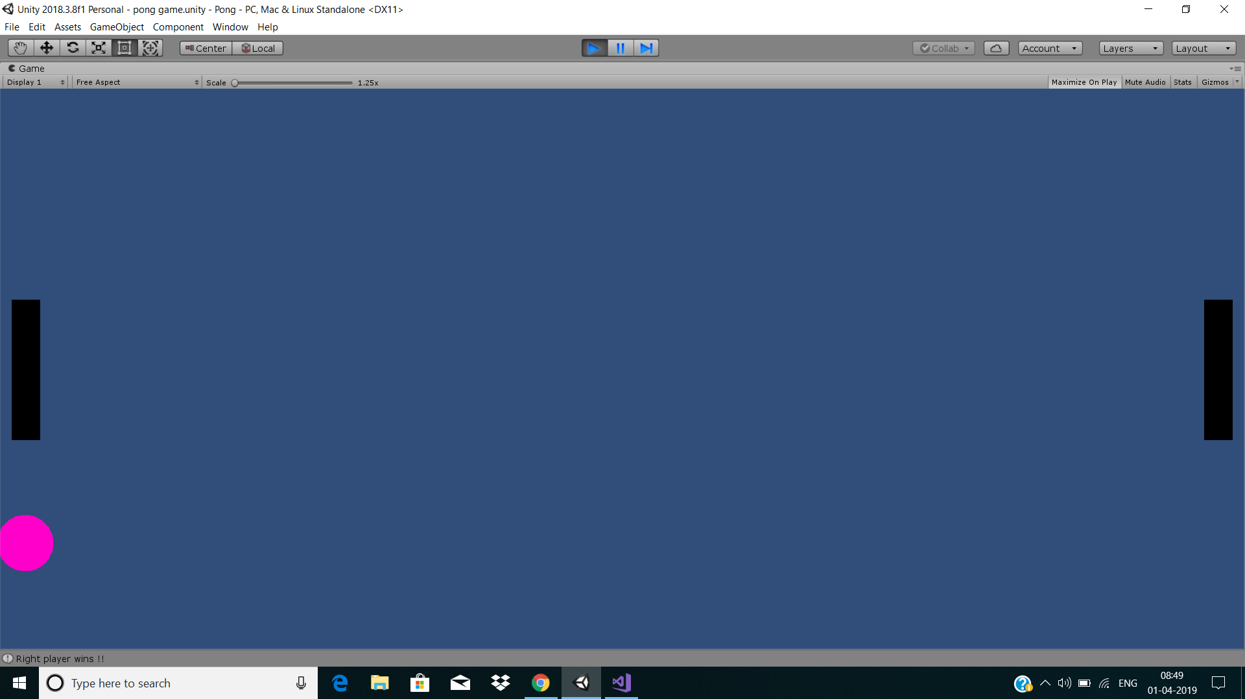

**4.6 Left player wins:**

**When the ball is missed by Right paddle.The result will be shown as Left player wins.**

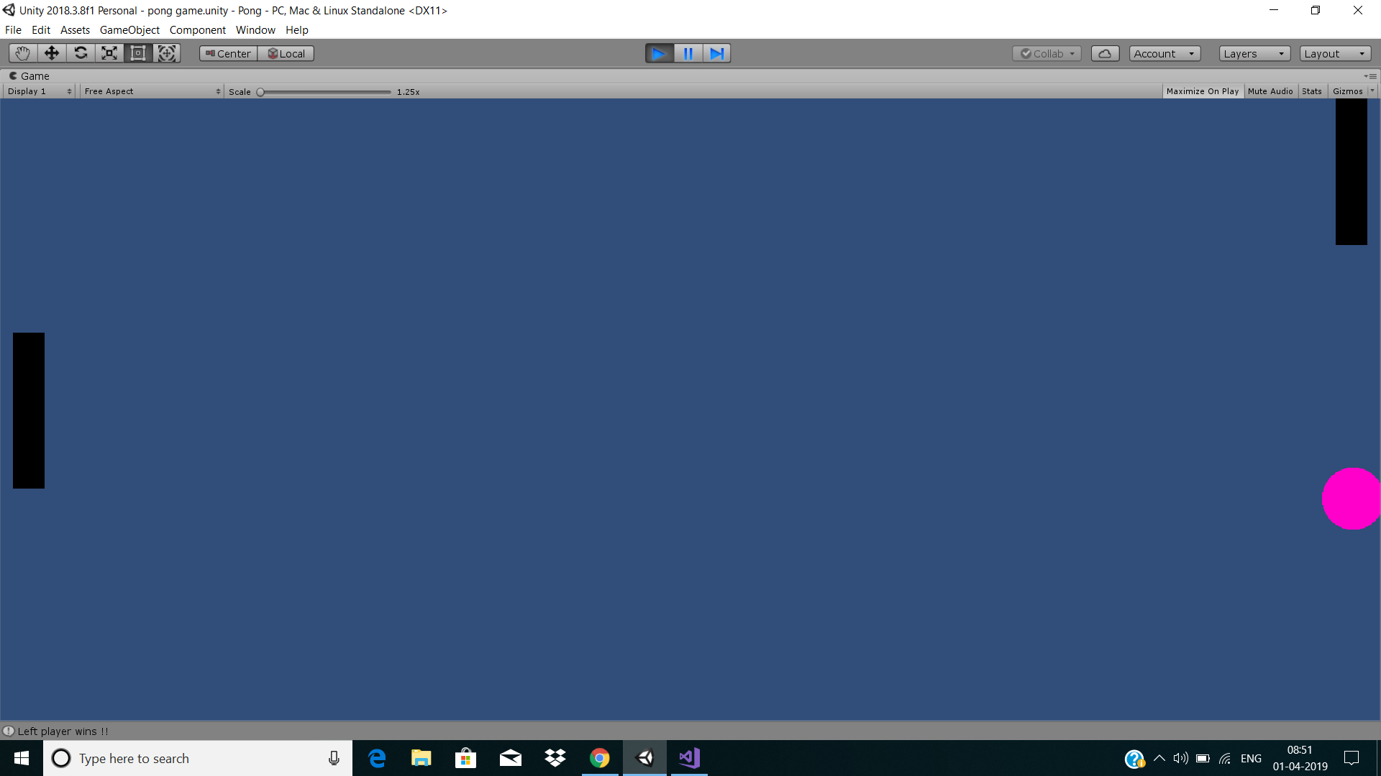

|  |
| --- |
| **5. Phase 3: The implementation** |

**5.1 Coding of GameManager:**

**using System.Collections;**

**using System.Collections.Generic;**

**using UnityEngine;**

**public class GameManager : MonoBehaviour**

**{**

**public Paddle paddle;**

**public Ball ball;**

**public static Vector2 bottomLeft;**

**public static Vector2 topRight;**

**// Use this for initialization**

**void Start()**

**{**

**// Convert screen's pixel coordinate into game's coordinate**

**bottomLeft = Camera.main.ScreenToWorldPoint(new Vector2(0, 0));**

**topRight = Camera.main.ScreenToWorldPoint(new Vector2(Screen.width, Screen.height));**

**//Create ball**

**Instantiate(ball);**

**//Create two paddles**

**Paddle paddle1 = Instantiate (paddle) as Paddle;**

**Paddle paddle2 = Instantiate (paddle) as Paddle;**

**paddle1.Init(true); // right paddle**

**paddle2.Init(false); // left paddle**

**}**

**}**

**5.2 Coding of Paddle:**

**using System.Collections;**

**using System.Collections.Generic;**

**using UnityEngine;**

**public class Paddle : MonoBehaviour**

**{**

**[SerializeField]**

**float speed;**

**float height;**

**string input;**

**public bool isRight;**

**// Use this for initialization**

**void Start()**

**{**

**height = transform.localScale.y;**

**speed = 10f;**

**}**

**public void Init(bool isRightPaddle)**

**{**

**isRight = isRightPaddle;**

**Vector2 pos = Vector2.zero;**

**if (isRightPaddle)**

**{**

**// Place paddle on the right of screen**

**pos = new Vector2(GameManager.topRight.x, 0);**

**pos -= Vector2.right * transform.localScale.x; // move a bit to the left**

**input = "PaddleRight";**

**}**

**else**

**{**

**// place paddle on the left of screen**

**pos = new Vector2(GameManager.bottomLeft.x, 0);**

**pos += Vector2.right * transform.localScale.x; // move a bit to the left**

**input = "PaddleLeft";**

**}**

**// Update this paddle's position**

**transform.position = pos;**

**}**

**// Update is called once per frame**

**void Update()**

**{**

**//now let's move the paddle!**

**// GetAxis is a number between -1 to 1 (-1 for down, 1 for up)**

**float move = Input.GetAxis(input) * Time.deltaTime * speed;**

**// Restrict paddle movement**

**// if paddle is too low and user is continuing to move down, stop**

**if (transform.position.y < GameManager.bottomLeft.y + height / 2 && move < 0)**

**{ move = 0; }**

**// if paddle is too low and user is continuing to move up, stop**

**if (transform.position.y > GameManager.topRight.y - height / 2 && move > 0)**

**{ move = 0; }**

**transform.Translate(move * Vector2.up);**

**}**

**}**

**5.3 Coding of Ball:**

**using System.Collections;**

**using System.Collections.Generic;**

**using UnityEngine;**

**public class Ball : MonoBehaviour**

**{**

**[SerializeField]**

**float speed;**

**float radius;**

**Vector2 direction;**

**// Use this for initialization**

**void Start()**

**{**

**speed = 10f;**

**direction = Vector2.one.normalized; // direction is(1,1) normalized**

**radius = transform.localScale.x / 2; // half the width**

**}**

**// Update is called once per frame**

**void Update()**

**{**

**// Boune off top and bottom**

**transform.Translate(direction * speed * Time.deltaTime);**

**if (transform.position.y < GameManager.bottomLeft.y + radius && direction.y < 0)**

**{ direction.y = -direction.y; }**

**if (transform.position.y > GameManager.topRight.y - radius && direction.y > 0)**

**{ direction.y = -direction.y; }**

**// Game over**

**if (transform.position.x < GameManager.bottomLeft.x + radius && direction.x < 0)**

**{ Debug.Log("Right player wins !!");**

**// For now,just freeze time**

**Time.timeScale = 0;**

**enabled = false; // Stop updating script**

**}**

**if (transform.position.x > GameManager.topRight.x - radius && direction.x > 0)**

**{Debug.Log("Left player wins !!");**

**// For now,just freeze time**

**Time.timeScale = 0;**

**enabled = false; // Stop updating script**

**}**

**}**

**void OnTriggerEnter2D(Collider2D other)**

**{**

**if (other.tag == "Paddle")**

**{**

**bool isRight = other.GetComponent<Paddle>().isRight;**

**// if hitting paddle and moving right, flip direction**

**if (isRight == true && direction.x > 0)**

**{**

**direction.x = -direction.x;**

**}**

**// if hitting paddle and moving left, flip direction**

**if (isRight == false && direction.x < 0)**

**{**

**direction.x = -direction.x;**

**}**

**}**

**}**

**}**

**6.Testing:**

**After succesful implementation of coding testing is done,just by simply running the project and Pong game is ready to play.**

➢ **GENERAL REFERENCES**

**www.unity3d.com**

**www.thefree3dmodels.com**

**www.archive3d.net**

✓✓ **www.google.in** ✓✓✓ **www.w3schools.com** ✓

✓ **www.codeproject.in**

**www.stackoverflow.com**

**www.youtube.com**

**Unity Asset Store**

✓